Game of Fuels
Louise Dynes (SBRC Outreach and Communications Officer) applied for and was awarded some funding from the University of Nottingham’s small grant fund and together with match funding from the BBSRC’s Network in Biotechnology and Bioenergy; C1net, Louise has developed a game with the C1net Network Manager, Jacque Minton.

Concept:

The initiative was to produce an interactive game with the aim to help educate pupils about renewable energy particularly biofuels and the techniques and processes involved in developing them. The game is to be used as a permanent outreach tool to play in schools and at science fairs in order to help educate secondary school pupils and adults as part of a stimulating and fun activity.

Aims and impact of the game:
1. Raise awareness about renewable energy focusing particularly on bioenergy and to provide an understanding of climate change and global warming, as well as the processes involved in producing them and the challenges in mitigating climate change. This will be achieved by designing the game in a way to help educate pupils as part of a stimulating and fun activity.
2. The game complements sections of Key Stage 3 of the National Curriculum, including: cells and organisation, material cycles and energy, cellular respiration, DNA and genes. The game will also give pupils an introduction to microbes and microbiology
3. Parts of the game will give players not only scientific knowledge surrounding this topic, but also an insight into the social aspects too. This will include facts about political, publicity and people matters with the intension to give the players real life scenarios about how bioenergy is currently perceived
4. The game will be created as a permanent tool which can be reused throughout schools and science fair outreach programmes creating a sustainable activity with long term benefits
5. By using this game we hope to raise aspirations in this area of science and biotechnology with the aim that students will consider studying this new and exciting topic at University in the future

Development and focus groups:
Once a draft copy of the game was created, we held a series of focus groups involving PhD students, research fellows and social scientists. The focus groups were set up to play the draft game, generate discussion about the game including its aims and objectives and to ask the group for help with some of the scientific background. We also asked them about how we could improve and enhance the game.
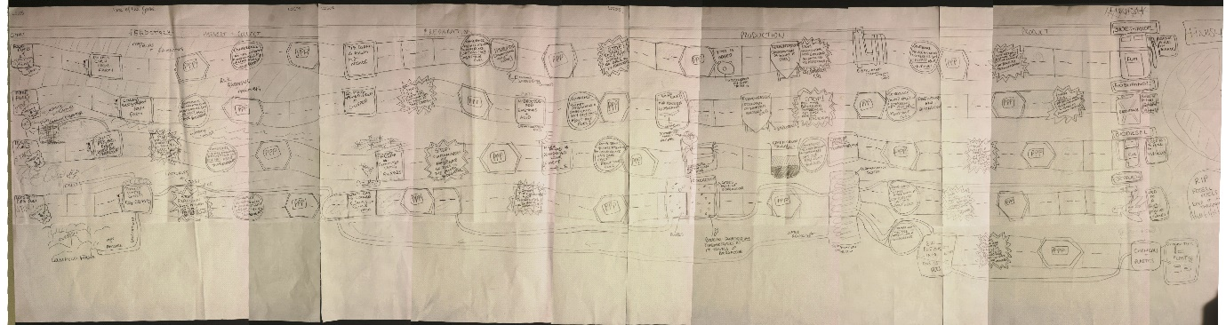
The first draft copy of the Game of Fuels

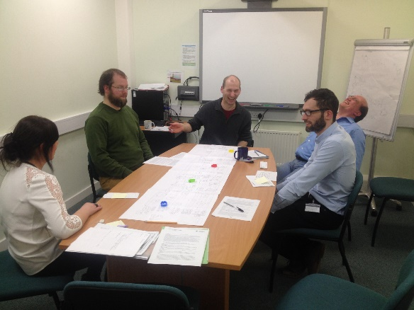
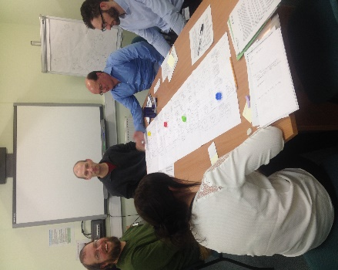

One of the focus groups playing the draft version of the game and generating discussion

The final product:
The final copy of the game was printed on durable vinyl material measuring width: 60cm and length: 170cm.
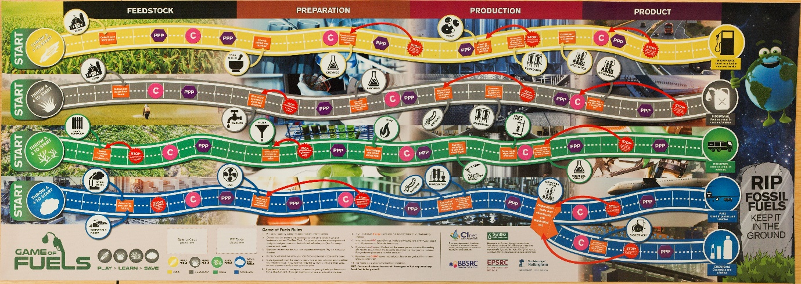
Final version of the Game of Fuels printed onto vinyl material

The game consists of the following materials:
- Game board (printed on a Vinyl mat)
- x4 coloured wooden trucks
- x4 coloured wooden cubes
- x4 fuel fact cards
- x1 die
- Glossary of terms
- Game of Fuels background information card
- PPP (Politics, Publicity & People) cards
- Q (question) cards
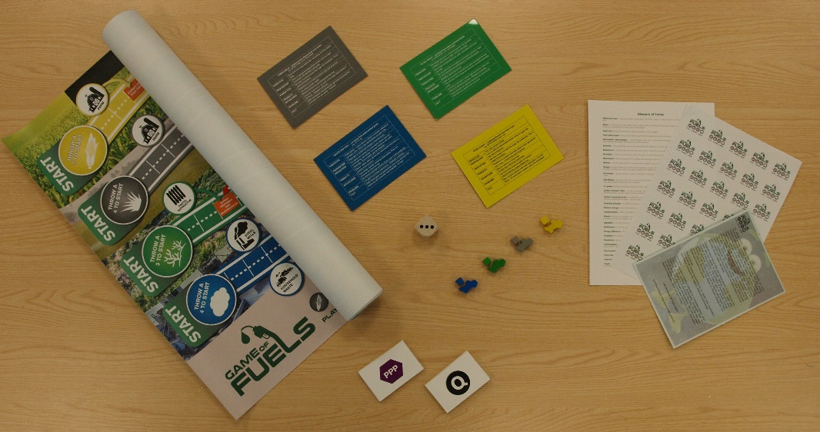
- Game of Fuels stickers

Game of Fuels materials
How to play the game:
Each player chooses a game-piece consisting of a miniaturized pick-up truck containing a feedstock; they will also be given a fact card with information on about their particular feedstock. Each player rolls a die and moves their vehicle ahead from the feedstock origins through the preparation and production processes to the final product.
There are challenges along the road; if a player lands on a PPP (Politics, Publicity & People) space they will be given a fact which can either hinder or enhance their movement along the board. If a player lands on a normal road space, they will be required to answer the question correctly in order to continue and if a player lands on a C space (Conference) this means they are at a scientific meeting and will need to say, out-loud, one sentence about their fuel from their fuel fact card and everybody playing gives them a round of applause. There are also STOP! space, if the player lands on this space they must read out their disaster and go back the number of spaces as instructed.
The players proceed through the necessary steps and required technologies for a sustainable bioenergy production. The game concludes when one of the players has developed their entire bio-industrial line production and has made their final product.

Future plans:
We are planning to trial the game in autumn 2016 at 5 local University of Nottingham, Widening Participation target schools. We will run sessions of the game at these schools and will include classes from years 7, 8 & 9. Following the trial we will adapt the game as necessary and advertise it to other local schools, community groups and at science fairs.

Evaluation and effectiveness:
This will be measured by using teacher and participant feedback forms following playing the game, all feedback will be evaluated and reported on.

